**CEE 526 Finite Elements for Engineers**

**Modeling Project 1-1**

Due Date: Mar. 23rd, 2016

Author: Michael Justice

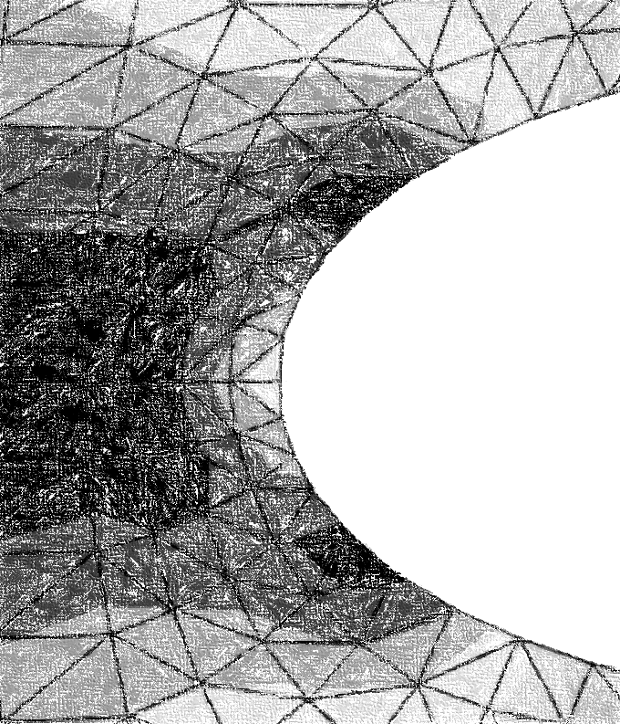

Table of Contents

Steel Plate with Circular Hole in Center 3

Problem Description 3

Finite Element Model 4

Results (and Convergence Results) 6

Conclusions 9

References 10

List of Figures

Figure 1 – Problem Figure 3

Figure 2 - FEA Model with Partitions 4

Figure 3a – Deformed Shape Using Q4 Elements 6

Figure 3b – Deformed Shape Using T3 Elements 7

Figure 4 – Convergence of Q4, T3 Elements 8

List of Equations

Equation 1 - Stress at Hole 5

List of Tables

Table 1 – Q4 Mesh Summary 7

Table 2– T3 Mesh Summary 8

# Steel Plate with Circular Hole in Center

## Problem Description

For this FEA (Finite Element Analysis) project, the goal was to a) determine the maximum von Mises stress in a steel plate with a perfect circular hole in the center, and b) determine the deformed shape of the hole. These two tasks were accomplished using the FEA program Abaqus. The free (student) version of the program was used for this project. Figure 1 below is a sketch of the steel plate.

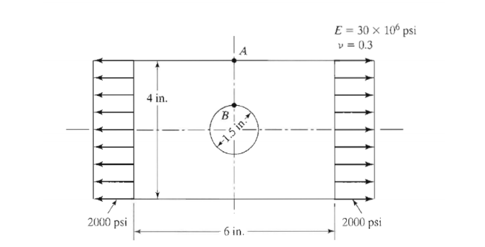

X +

Y+

|  |
| --- |
| Figure – Problem Figure |

The model is a thin steel rectangular plate with dimensions 6”x4”x1” with an applied uniform (static) loading in the X-direction of 2000 psi. The plate has a perfect circular hole in the center with a diameter of 1.5”. The elastic modulus of the steel is 30e6 psi with a Poisson’s ratio of 0.3.

## Finite Element Model

The finite element model (FEM) was constructed using the student version of Abaqus. The limitation of the student version is that all models are limited to 1000 nodes or less. Therefore, only *linear* Q4 and T3 elements were used to stay under the 1000 node limit. These two element types alone were also chosen to ensure a proper systematic approach to yield an accurate result for the convergence analysis.

The model was created on the basis that the plate has an elastic (linear), isotropic material with an elastic modulus and Poisson’s ratio as shown in Figure 1. The model was assumed to be of plane-stress, since the thickness of the plate is comparatively small to the width and height, and that the loading is only in the X-Y Plane. Because of the assumption of plane stress, there is no shear stress in the X-Z or Y-Z plane (and consequently no strain in those planes either). Since there is no applied loading in the Z-direction (which constitutes the application of plane-stress), there is no strain in the Z-direction.

Below is Figure 2, which illustrates the geometry of the partitions used for the model.

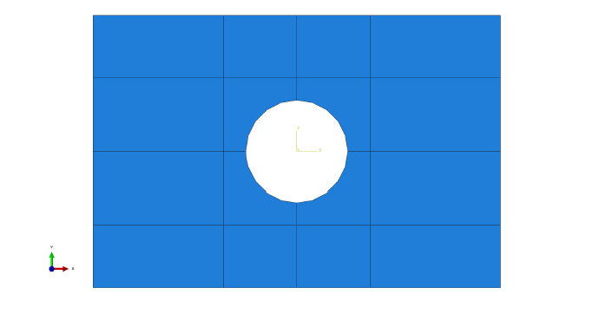

**Partition**

**Fixity Condition**

|  |
| --- |
| Figure 2 - FEA Model with Partitions |

The model was partitioned in this way to allow a more refined mesh around the perimeter of the hole. From elementary fracture mechanics, it is known that stress will concentrate around the hole, therefore more elements around the perimeter will yield a better result.

The loading was applied along the vertical edges of the plate, as shown in Figure 1. The boundary (or fixity) conditions were such that the plate was pinned in the X-Y directions, as shown above in Figure 2 (a *roller support was applied on each axis of symmetry*, yielding a pinned condition overall).

From the general stress concentration equation for a flat plate with uniform loading on the sides[1]:

Equation 1 - Stress at Hole

Where is the max stress at the hole,

is the applied stress (2000 psi in this case),

is the half perpendicular dimension of the length of the hole to , and

is the radius of curvature and in this case, half the diameter.

Therefore, theoretically the stress at the hole should be:

## Results (and Convergence Results)

Applying the 2000 psi uniform stress at the edges of the plate, the following deformed shape was generated (Figure 3).

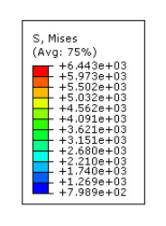`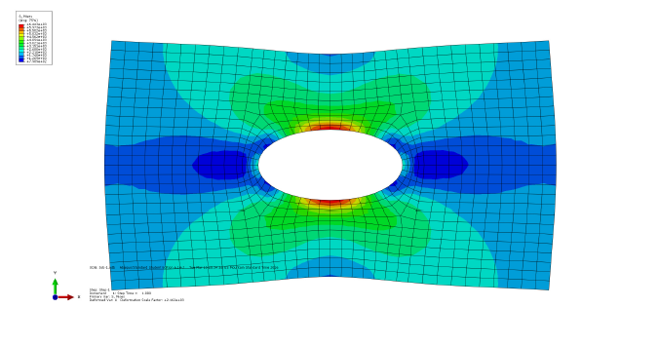

**Top Edge**

**Bottom Edge**

**Right Edge**

**Left Edge**

**Point B**

|  |
| --- |
| Figure a – Deformed Shape Using Q4 Elements |

Note that the hole deformed in a predictable manner – the left and right edges of the hole stretched outwards due to the applied load in that direction. The top and bottom edges of the hole displaced inwards due to Poisson’s effect, which was expected. The following figure (Figure 3b) illustrates the deformed shape of the plate with T3 elements.

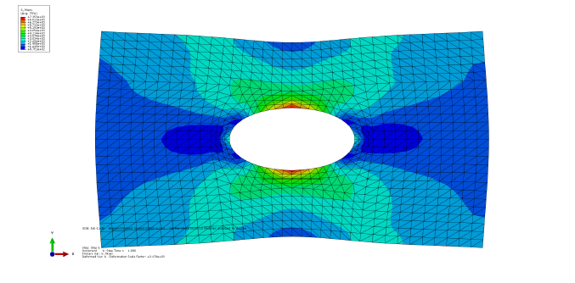

**Point B**

**Top Edge**

**Bottom Edge**

**Right Edge**

**Left Edge**

|  |
| --- |
| Figure 3b - Deformed Shape Using T3 Elements |

The stress table to the left of Figure 3a, 3b is the von Mises stress color legend for the model. Below is Table 1, which summarizes the finite element result for the Q4 model.

Table – Q4 Mesh Summary

|  |  |  |  |  |
| --- | --- | --- | --- | --- |
| **Model** | **Element Type** | **Number of Nodes** | **Number of Elements** | **Point B** |
| **Max von Mises Stress (psi)** |
| Mesh 1 | Q4 | 60 | 43 | 3916.26 |
| Mesh 2 | Q4 | 128 | 100 | 5373.83 |
| Mesh 3 | Q4 | 235 | 196 | 5647.72 |
| Mesh 4 | Q4 | 591 | 526 | 6128.56 |
| Mesh 5 | Q4 | 968 | 884 | 6443.18 |

From Table 1, it can be seen that the von Mises stress converges from below, which is expected. Below is Table 2, which summarizes the finite element result for the T3 model.

Table – T3 Mesh Summary

|  |  |  |  |  |
| --- | --- | --- | --- | --- |
| **Model** | **Element Type** | **Number of Nodes** | **Number of Elements** | **Point B** |
| **Max Von Mises Stress (psi)** |
| Model 1 | T3 | 60 | 86 | 4178.30 |
| Model 2 | T3 | 128 | 200 | 6398.49 |
| Model 3 | T3 | 235 | 392 | 6703.33 |
| Model 4 | T3 | 591 | 1182 | 7246.82 |
| Model 5 | T3 | 968 | 1936 | 7352.51 |

From Table 2, it can again be seen that the von Mises stress converges from below. Figure 4 below illustrates this convergence and compares the two element types.

|  |
| --- |
| Figure 4 – Convergence of Q4, T3 Elements |

From Figure 4, it can be seen that T3 elements converge faster than Q4 elements, due to the fact that a model with the T3 element type will have twice as many elements than that of the same model with the Q4 element type.

## Conclusions

The following observations from the above results can be made about the finite element analysis of the steel plate:

1. T3 elements converge faster than Q4 elements, or in other words, higher-order elements converge faster than lower-order elements.
2. Stresses converge from below.
3. The maximum von Mises Stress was located at the top/bottom of the hole.

## References

1. Neithalath, Narayanan. "Fracture Mechanics." (2015): 89. *ASU*. Web. 15 Jan. 2015.